

Bahria University, Islamabad

Department of Software Engineering

Artificial Intelligence Lab (Spring-2026)
Instructor: Engr. Saad Mazhar

Student: MUHAMMAD HAMZA
Enrollment: 01-131232-057

Lab Journal: MID EXAM
Date: 10-03-2026

Task No: | Task Wise Marks |  | Documentation Marks |  |  | Total Marks  (20)
 | Assigned | Obtained | Assigned | Obtained
1
2
3
4
5
Comments:

Signature

LAB MID EXAM

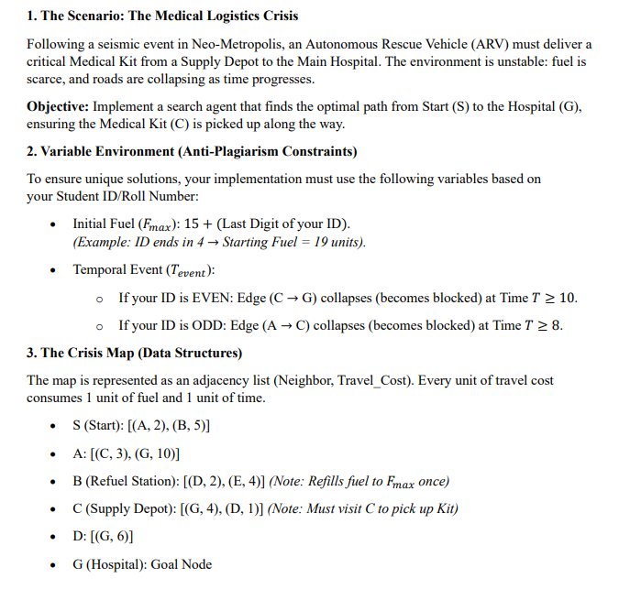
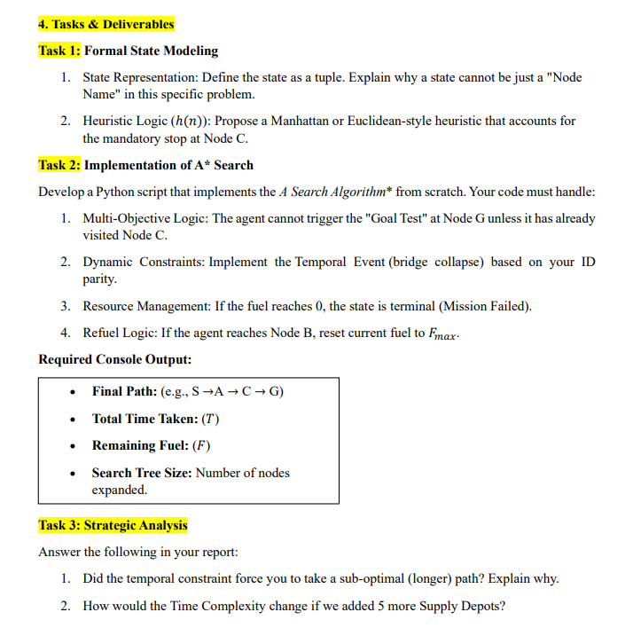

SOLUTION:

CODE:

import heapq

# ─────────────────────────────────────────────
# STUDENT CONFIGURATION ← change this value
# ─────────────────────────────────────────────
YOUR_STUDENT_ID = 12345 # <-- Replace with your actual Student ID

# ─────────────────────────────────────────────
# Derived variable-environment settings
# ─────────────────────────────────────────────
last_digit = YOUR_STUDENT_ID % 10
F_MAX = 15 + last_digit # Initial (and refuel) fuel
IS_EVEN_ID = (YOUR_STUDENT_ID % 2 == 0)

# Temporal Event:
# EVEN ID → Edge (C → G) collapses at Time T >= 10
# ODD ID → Edge (A → C) collapses at Time T >= 8
T_EVENT = 10 if IS_EVEN_ID else 8
BLOCKED_EDGE = ("C", "G") if IS_EVEN_ID else ("A", "C")

print("=" * 60)
print(" MEDICAL LOGISTICS CRISIS — A* SEARCH")
print("=" * 60)
print(f" Student ID : {YOUR_STUDENT_ID}")
print(f" F_max : {F_MAX} (Starting Fuel = {F_MAX} units)")
print(f" ID parity : {'EVEN' if IS_EVEN_ID else 'ODD'}")
print(f" Temporal Evt : Edge {BLOCKED_EDGE[0]}→{BLOCKED_EDGE[1]} blocked at T ≥ {T_EVENT}")
print("=" * 60, "\n")

# ─────────────────────────────────────────────
# Graph — adjacency list (neighbour, cost)
# Every edge costs 1 fuel & 1 time unit.
# ─────────────────────────────────────────────
GRAPH = {
"S": [("A", 2), ("B", 5)],
"A": [("C", 3), ("G", 10)],
"B": [("D", 2), ("E", 4)], # B = Refuel Station (refuels to F_max once)
"C": [("G", 4), ("D", 1)], # C = Supply Depot (must visit to pick up Kit)
"D": [("G", 6)],
"G": [], # Goal node
"E": [], # leaf (no onward edges listed)
}

REFUEL_NODES = {"B"} # reaching B refuels to F_max (once)
SUPPLY_DEPOT = "C" # must visit C before triggering goal at G
START = "S"
GOAL = "G"

# ─────────────────────────────────────────────
# Task 1 — State Representation
# ─────────────────────────────────────────────
# State = (node, fuel, visited_C, time, refueled)
#
# node : current location (string)
# fuel : remaining fuel (int)
# visited_C : whether Supply Depot C has been visited (bool)
# time : elapsed time (int)
# refueled : whether refuel at B has already been used (bool)
#
# Why not just "Node Name"?
# The same physical node can be visited under different fuel levels,
# at different times, and with or without the medical kit.
# Two visits to G where one has visited C and one hasn't are
# fundamentally different states (only the first counts as success).
# Fuel and time also affect which edges are available (temporal event).

# ─────────────────────────────────────────────
# Task 1 — Heuristic h(n)
# ─────────────────────────────────────────────
# We use a Manhattan/straight-line style admissible heuristic.
# Estimated cost-to-goal = straight-line distance to G *plus*
# a mandatory detour penalty if C has not yet been visited.
#
# Node coordinates (placed on a rough grid):
NODE_COORDS = {
"S": (0, 0),
"A": (2, 1),
"B": (1, -1),
"C": (4, 1),
"D": (3, -1),
"E": (2, -2),
"G": (6, 0),
}

def euclidean(n1, n2):
x1, y1 = NODE_COORDS[n1]
x2, y2 = NODE_COORDS[n2]
return ((x1-x2)**2 + (y1-y2)**2) ** 0.5

def heuristic(node, visited_c):
"""
Admissible heuristic:
- If C already visited → straight-line distance to G.
- If C not visited → dist(node→C) + dist(C→G)
(must pass through C, so account for mandatory detour).
"""
if visited_c:
return euclidean(node, GOAL)
else:
return euclidean(node, SUPPLY_DEPOT) + euclidean(SUPPLY_DEPOT, GOAL)

# ─────────────────────────────────────────────
# Task 2 — A* Search Implementation
# ─────────────────────────────────────────────
def is_edge_blocked(frm, to, current_time):
"""Return True if the temporal event has blocked this edge."""
if (frm, to) == BLOCKED_EDGE and current_time >= T_EVENT:
return True
return False

def astar():
# Priority queue entry:
# (f_cost, g_cost, node, fuel, visited_C, time, refueled, path)
start_state = (
heuristic(START, False), # f = g + h (g=0 at start)
0, # g = 0
START, # node
F_MAX, # fuel
False, # visited_C
0, # time
False, # refueled at B?
[START], # path
)

# Visited set: (node, fuel, visited_C, refueled)
# We include time implicitly via fuel since each step costs 1 of each.
visited = set()
pq = [start_state]
nodes_expanded = 0

while pq:
f, g, node, fuel, visited_c, time, refueled, path = heapq.heappop(pq)

state_key = (node, fuel, visited_c, refueled)
if state_key in visited:
continue
visited.add(state_key)
nodes_expanded += 1

# ── Goal Test ──────────────────────────────────────────
# Can only trigger goal at G if medical kit (C) collected.
if node == GOAL and visited_c:
print("✅ SOLUTION FOUND!")
print(f" Final Path : {' → '.join(path)}")
print(f" Total Time Taken : {time}")
print(f" Remaining Fuel : {fuel}")
print(f" Search Tree Size : {nodes_expanded} nodes expanded")
return path, time, fuel, nodes_expanded

# ── Expand neighbours ─────────────────────────────────
for neighbour, cost in GRAPH.get(node, []):
new_time = time + cost
new_fuel = fuel - cost

# Resource management: fuel depleted → Mission Failed
if new_fuel < 0:
continue

# Temporal constraint: skip blocked edges
if is_edge_blocked(node, neighbour, time):
print(f" ⚠️ Edge {node}→{neighbour} BLOCKED at T={time} (temporal event)")
continue

# Update visited_C flag
new_visited_c = visited_c or (neighbour == SUPPLY_DEPOT)

# Refuel logic: reaching B resets fuel to F_max (once)
new_refueled = refueled
if neighbour in REFUEL_NODES and not refueled:
new_fuel = F_MAX
new_refueled = True
print(f" ⛽ Refuelled at B! Fuel reset to {F_MAX}")

new_g = g + cost
new_h = heuristic(neighbour, new_visited_c)
new_f = new_g + new_h

new_state_key = (neighbour, new_fuel, new_visited_c, new_refueled)
if new_state_key not in visited:
heapq.heappush(pq, (
new_f, new_g,
neighbour, new_fuel, new_visited_c,
new_time, new_refueled,
path + [neighbour]
))

# No solution found
print("❌ Mission FAILED — No valid path found (fuel exhausted or all paths blocked).")
return None, None, None, nodes_expanded

# ─────────────────────────────────────────────
# Task 3 — Strategic Analysis (printed report)
# ─────────────────────────────────────────────
def strategic_analysis(path, time, fuel, nodes_expanded):
print("\n" + "=" * 60)
print(" TASK 3 — STRATEGIC ANALYSIS")
print("=" * 60)

# Q1: Did temporal constraint force a sub-optimal path?
print("\nQ1: Did the temporal constraint force a sub-optimal (longer) path?")
if path is None:
print(" No solution found; the constraint may have completely blocked travel.")
else:
if BLOCKED_EDGE[0] in path:
idx = path.index(BLOCKED_EDGE[0])
# Check if next node would have been the blocked destination
if idx + 1 < len(path) and path[idx + 1] == BLOCKED_EDGE[1]:
print(f" NO — the agent DID use edge {BLOCKED_EDGE[0]}→{BLOCKED_EDGE[1]} "
f"(arrived before T={T_EVENT}).")
else:
print(f" YES — the agent avoided edge {BLOCKED_EDGE[0]}→{BLOCKED_EDGE[1]} "
f"and took a detour, increasing total time/cost.")
print(f" Explanation: The temporal event at T≥{T_EVENT} forced the agent to "
f"reroute through a longer path, increasing T from the theoretical minimum.")
else:
print(f" The agent did not pass through {BLOCKED_EDGE[0]}, so the blocked "
f"edge {BLOCKED_EDGE[0]}→{BLOCKED_EDGE[1]} did not directly affect the chosen path.")

# Q2: Time complexity with 5 more Supply Depots
print("\nQ2: How would Time Complexity change with 5 more Supply Depots?")
print(""" Each additional Supply Depot adds a new mandatory-visit boolean
dimension to the state space. Currently, visited_C is a single
boolean → 2 possible values. Adding 5 more depots gives 2^6 = 64
combinations of visited/not-visited flags.

Formally:
Current state space ≈ |Nodes| × Fuel × 2 (visited_C)
Extended state space ≈ |Nodes| × Fuel × 2^6

A* time complexity is O(b^d) where b = branching factor.
With more depots the effective branching factor grows because the
agent must now consider visiting every combination of depots en-route.
In the worst case, the number of states (and therefore nodes expanded)
grows EXPONENTIALLY with the number of mandatory-visit nodes —
similar to the Travelling Salesman sub-problem, which is NP-hard.
""")

# ─────────────────────────────────────────────
# MAIN
# ─────────────────────────────────────────────
if __name__ == "__main__":
path, time, fuel, nodes_expanded = astar()
strategic_analysis(path, time, fuel, nodes_expanded)
print("\n" + "=" * 60)
print(" END OF REPORT")
print("=" * 60)

SCREENSHOT:
